CLOSEJOB logical value of YES will Automatically Calculate Waste

The N-K-1 parameter called CLOSE job indicates when to close the job but this may also automatically calculate waste based on the board issued to the job as well as the quantity produced on each machine. In the example, below two board sheets were issued to the job for a total of 5,500 sheets. The sheeting machine posted 5000 sheets, the press posted 4900 sheets, the die cutter ran 4800 and the gluer produced 4700 boxes. Please note, although there was no wasted posted to any machine and the production did not post the correct quantities, the waste still reflects the waste based on actual material issued to the job less the quantity produced for each operation. Therefore, the first operation absorbed the 500 wasted sheets, which is the difference between the 5,500 issued and the 5000 produced via sheeting.
Likewise, the difference between each machine reflects the additional waste.

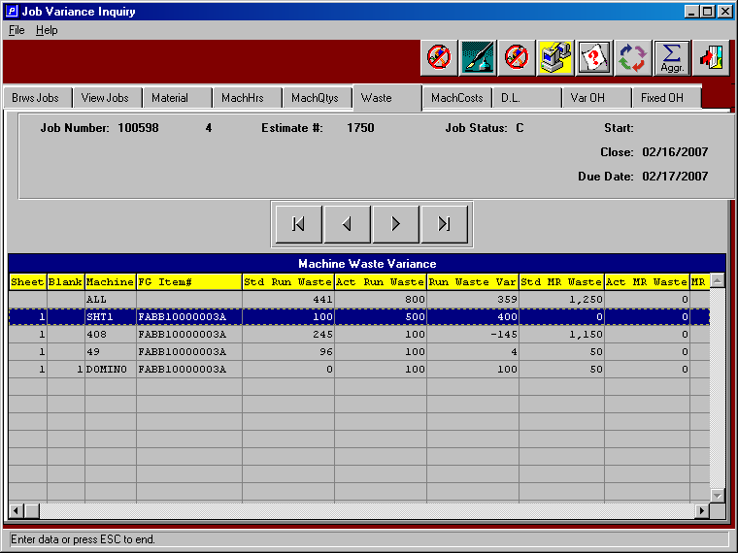

Job summary report via the menu J-R-3 will also reflect the actual waste.

